Cells of Currents and Catastrophes
- At any given moment, somewhere in the world...winds of change are blowing. The main question is: why? Well, in the end, wind currents are the electrical conduits of the globe's atmospheric power grid. It is all about distribution, power, force and pressure. The atmosphere is a constantly churning soup of hot and cold air masses, vainly trying to settle down into a still pool of lukewarm air because energy from the sun is constantly stirring the metaphorical pot.
- Hot air expands and becomes buoyant. Cool air contracts and tends to sink. This process results in convective currents moving through the atmosphere in large loops called cells. There are three different types of cells in each hemisphere (North and South), and the movement of the large loops of air through each cell is driven by different processes...in fact, technically only two of them are actually loops of convection currents.
- The first cells are named for their discoverer. They are the Hadley Cells, and they are found directly adjacent to the Equator. These loops of air are driven by the heating of air at the equator. The heated air is buoyant, and floats upwards. It is then replaced by colder air flowing towards the equator. As the hot air rises, it expands as the air pressure above it lessens at higher altitudes. As it expands, it begins cooling off. Water vapor carried in the rising warmed air begins condensing to form clouds, which are carried up and away from the equator. By the time the air currents have reached roughly 30 degrees of latitude away from the equator, the air has cooled enough through expansion and rainstorms that it becomes dense enough to sink back towards the Earth. From there, the cool air flows back towards the equator, warming and picking up water vapor from oceans, lakes and rivers below. As these equator-bound trade winds move westward due to the Coriolis Effect, they finally return to the beginning of their cycle within the Hadley Cell.
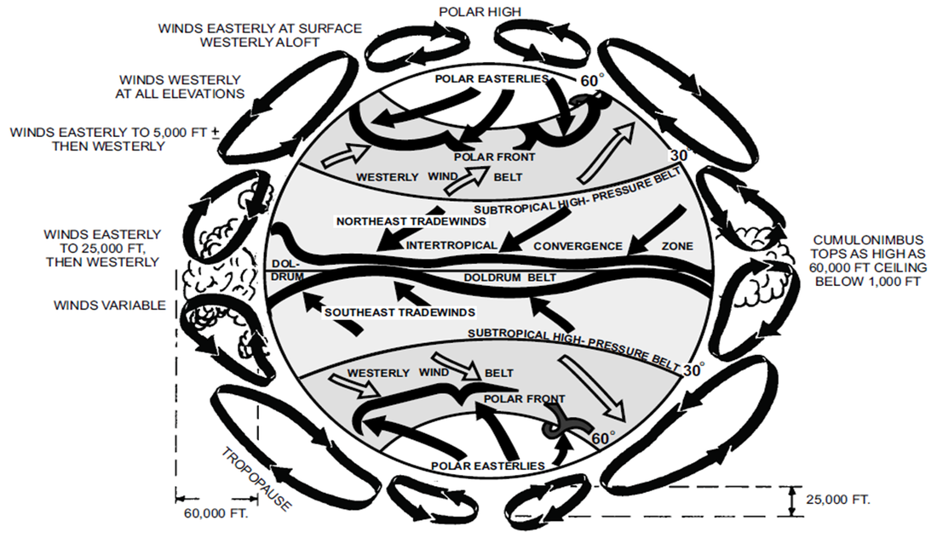
- At the poles, another cell is found. Predictably, it is called a (you guessed it) Polar Cell. As in the Hadley Cell, it is the difference between temperatures that drive this loop of air currents. The intensely cold air at the poles sinks and rolls towards the equator. Around 60 degrees of latitude, the air has warmed sufficiently that it no longer has the density to plow further away from the poles, but instead becomes buoyant, moving into the atmosphere before it slides back pole-wards, cooling and sinking as it goes. In a way, it can be said that the Polar Cell is driven more by the temperature and density of the polar air than anything else...but as in any convection current, it is all about the difference in temperature. In the case of the Polar Cells, the air is still rising close to the equator, and sinking close to the Poles. Like the Hadley Cells, the Polar Cells are rotating so that the winds in the upper troposphere are moving pole-wards, those near the ground are moving towards the equator, typically curving westward.
- The last piece of the cell puzzle is what sits in between the Polar Cells and the equatorial Hadley Cells. This is the region between the latitudes of 30 and 60 degrees, and they are known as the Mid-latitude Cells. Unlike the other cells, these areas have circulating currents of air that are not mainly driven by temperature differences. Instead, the currents of rising air at the boundary with the Polar Cells and sinking air at the edge of the Hadley Cell force the air trapped between them to circulate. Essentially, the Mid-latitude zone appears to be a giant eddy, rolling like a giant ball due to the friction of the cells neighboring it. In this case, the winds running near the ground flow away from the equator, and towards the poles, in this case curving eastward.
- It is within all these cells of air that weather really takes place. Since winds in the cells are made mostly by temperature differences, anything that can change air temperature can have major effects. One of the most important examples is when the sun heats up open water. Evaporation naturally follows, resulting in a mass of warm, humid air above the water. What happens next is a result of what is around the warm air. If there is a cold mass of air on top of it, then this results in a temperature inversion, where cold, denser air is sitting on top of warmer, more buoyant air. The problem here is that this situation is unstable. Somehow, the air must switch positions.
- Another event that can cause a temperature inversion is when a moving mass of cold air runs into a mass of warm air. Sometimes, if the cold front (which is what the leading edge of a cold mass of air is called) is moving fast enough and is large enough, it can slide up over the top of the warm air mass.
- Temperature inversions have a couple of predictable consequences. First, where the cool air meets the warm air, clouds form as the water vapor in the warm air cools off. Typically, this can result in large, water heavy clouds and the rainstorms that follow. In the case of a cold front temperature inversion, this can result in a cloud that extends almost all the way to ground level: this is sometimes called a wall cloud, and it is a typically warning sign that conditions are right for a...tornado.
- When a temperature inversion occurs, a simple way to solve the precarious situation of denser air balanced atop the warm air below is to allow the denser air to burrow down through the atmosphere below. This happens every time a bathtub is emptied, or a whirlpool forms: The heavier, denser material moves down through the buoyant material beneath along the easiest path of least resistance. It turns out that this path is a spiral...we might expect that air might move along the shortest path, which is (in four dimensional space-time) a straight line. In practice, though, a short line of cold air tunneling through warm air does not work: the friction from the currents of air moving in opposing directions creates innumerable tiny eddies, sometimes called turbulence. This turbulence wastes energy, and nature never wastes energy...so instead, fluids swirl around each other in a less turbulent spiral.
- A tornado occurs because of a temperature inversion, usually over land. They are most commonly found in the Midwest of the U.S., a region that finds cold fronts from the north mixing with warm fronts from the Gulf of Mexico. The mixing of the cool and warm air leads to condensation, clouds and thunderstorms that are the hallmarks of tornado weather. Tornados are relatively small scale structures, and they tend to last only a brief time that rarely extends past a few hours. This is because they rely on a temporary imbalance of cold air over warm. Once the air masses have switched positions and stabilized, the tornado will die away.
- On the other end of the spectrum are hurricanes. Hurricanes can reach epic sizes and last for days, because hurricanes (also called cyclones) are large rotating systems that rely on evaporation of warm ocean water to create the updrafts that lead to a large vortex (or spiral) of cooler upper air exchanging places with warm lower air. The winds associated with hurricane systems are also tremendously powerful: they are capable of driving walls of water over 7 meters high in front of an advancing hurricane. In the case of hurricanes, the system is actually more like a convection current, where the warm water acts like the heat source. Warm water evaporates, creating an updraft, which increases wind speed, which causes more evaporation from the ocean surface, which creates more updraft...on and on, increasing the hurricane's force and speed with each moment.
- When the hurricane reaches land, it will deliver huge quantities of water as the evaporated water condenses and falls as precipitation. Winds will be capable of tearing down trees and houses, and the waves in front of the storm will reach land as a storm surge: a flood of water much higher than usual. This is the worst the land will experience. As the cyclone moves over the continent, it will lose access to the warm water that was powering it...before long, it will die away as thunderstorms and high winds before disappearing altogether...speaking of thunderstorms, we will need to discuss lightning, but that will wait.
Answer the following Questions in the SARs format.
1. What happens to warmer air? Cooler air?
2. What happens in a Hadley Cell? Why?
3. What happens in a Polar cell? Why?
4. What happens in the mid-latitude cells, and why?
5. What is a temperature inversion?
6. What can cause temperature inversions?
7. How do tornadoes form?
8. How do hurricanes form?
9. What is different and similar about tornadoes and hurricanes?
10. From the overall text, what direction do winds curve in when moving away from the equator? Moving towards?

