Moving Matter
Everything is moving. The air around you is moving. Large rivers of atmosphere are rushing through the skies, and smaller rivulets are coursing through your room. Inside those moving ribbons of air, smaller swirls and eddies flow. Inside those, molecules of nitrogen, argon, oxygen and carbon dioxide gas twist and flex and vibrate as they soar around, crashing into each other and into the bent shapes of molecules of water vapor, and pollen, and dust, and skin flakes.
Speaking of skin, your own skin is moving, even if you don't feel it. The proteins that you are made of may be strung together into sheets and fibers and lattices, but they are still twisting, and shaking, and jiggling around. In fact, if you could randomly choose any speck of matter in the entire universe, it would be moving at least a tiny, tiny amount.
We have a way of measuring how fast atoms and molecules are moving. The average speed of the particles that make up a substance is also called the temperature. The faster something is moving, the higher its temperature gets. The lower the temperature, the slower the atoms are twisting, flexing, and bouncing. Even in theory, no particle can ever stop moving, and reach what we call Absolute Zero Temperature.
So, why are we talking about movement, and temperature? Well, in a word, entropy. All the matter in the universe is slowly but surely spreading itself out into a nice, even cloud of lukewarm dust. This is happening because all particles move. This combined concept of random motion causing particles to spread out and cool down is known as entropy.
To visualize how this happens, think of a pile of tennis balls sitting in a field. Because they are piled together, the collection of tennis balls has low entropy: they are clustered together in an intentional seeming, non-random way. Now, to simulate how particles are constantly moving in random ways, we will have a horde of small children descend upon the tennis ball pyramid, and start hurling them about. A cloud of tennis balls will rise into the air, dropping, bouncing and rolling. Screaming kids will follow the tennis balls, grabbing whichever lands closest and throwing them time after time.
Envision what will happen to the initial stack of bright green tennis balls. As the seconds tick past, what will the field begin to look like?
Obviously, the balls will start spreading out as they get randomly thrown. The longer they move(the longer the kids keep throwing them) the more they will spread out, until the fence at the edge of the field is reached. Even though the balls have been randomly thrown, they should be spread out pretty evenly. This is what maximum entropy looks like. It is regular, it is predictable, but it is not organized.
Since particles are also moving randomly, if they are free to move around like in a plasma, gas or liquid, then they will also spread out, going from high concentrations in a small area to space themselves out evenly fill the largest volume possible: a low concentration. It is really important to realize that this is predictable, but it is also random and chaotic. While we can anticipate what the overall picture will look like in the end, with particles spread out and bouncing around, we cannot predict the path that any one particle will take.
When we talk about how particles spread out as they move, we are talking about diffusion. Particles always diffuse from high to low concentrations, and they almost always diffuse independently...this means that the various concentrations of other particles don't make a difference. In fact, different particles can diffuse in opposite directions! The only rule is that concentrations always decrease over time.
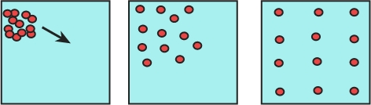
Now, water is a special case. Not that it behaves differently; water diffuses too. Water is so critical to life, though, that it has its own term: osmosis. Osmosis is when water diffuses through small holes in a barrier. This can have the effect of filtering out molecules larger than water molecules, and is especially important for cell membranes. (A cell membrane is the barrier that forms the "skin" of a cell.) Be careful, though, because the more stuff is dissolved or mixed into the water, the less water there is. When a solution has a lot of things dissolved into it, then there is less water, and more dissolved solutes. (A solution is a mix of a liquid, in this case water, with other liquids and solids dissolved in it. The things that are dissolved are called solutes. The liquid they dissolve into is called a solvent.) Water is more likely to flow into such a solution, to increase the low amount or concentration of water. (Remember, water diffuses from high concentrations to low concentrations, just like everything else.) When a solution has less dissolved in it, then more of it is made of water. In this case, there is a higher concentration of water, and water is more likely to flow out of such a solution.
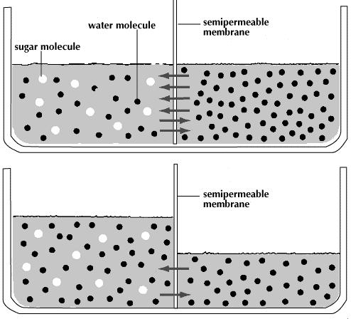
Again, because water is so important, there are specific words for each type of solution. (A solution is a mix of a liquid, in this case water, with other liquids and solids dissolved in it.) A solution has more solutes in it than a neighboring solution it is called hypertonic. (A solute is the thing that dissolves into a solvent. A solvent is the liquid that is doing the dissolving.) In this case, water will diffuse into the hypertonic solution if nothing prevents it. If there is a barrier in the way, then the water of course cannot move, but will instead just bounce off the walls of the container. If the barrier has holes big enough for some things like water to pass through, then it is called semi-permeable.
On the other hand, if a solution has more water and less solutes in it when compared to another, neighboring solution, then it is called hypotonic. In this case, water will move out of the hypotonic solution, and into the neighboring solution: it is moving away from an area of high concentration. When two neighboring solutions have the exact same amounts of water and solutes, then the solution is isotonic, and as much water randomly moves out of each solution as moves in.
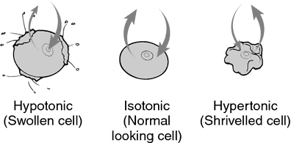
The tonicity of a solution is the most important when we consider the effects on cells. In a hypertonic solution, cells will lose water, shrivel up and even die. In hypotonic solutions, they will bloat and sometimes explode. In a universe that obeys such heartless laws of entropy, how can life hope to survive?

Use the text to create your own definitions for the following terms. Use the definitions rubric, and avoid reusing descriptive words that do not add to the explanation.
- Temperature
- Absolute Zero
- Entropy
- Diffusion
- Concentrations
- Osmosis
- Solution
- Solvent
- Solute
- Hypertonic
- Hypotonic
- Isotonic
Explain what happens t cells placed in these types of solutions:
- Hypertonic
- Hypotonic
- Isotonic
- Based on these definitions, create a general explanation for what “tonicity” likely means.

