Pocahontas

Say Thanks to the Authors Click http://www.ck12.org/saythanks (No sign in required)

To access a customizable version of this book, as well as other interactive content, visit www.ck12.org

CK-12 Foundation is a non-profit organization with a mission to reduce the cost of textbook materials for the K-12 market both in the U.S. and worldwide. Using an open-content, web-based collaborative model termed the FlexBook®, CK-12 intends to pioneer the generation and distribution of high-quality educational content that will serve both as core text as well as provide an adaptive environment for learning, powered through the FlexBook Platform®.

Copyright © 2013 CK-12 Foundation, www.ck12.org

The names “CK-12” and “CK12” and associated logos and the terms “FlexBook®” and “FlexBook Platform®” (collectively “CK-12 Marks”) are trademarks and service marks of CK-12
Foundation and are protected by federal, state, and international laws.

Any form of reproduction of this book in any format or medium, in whole or in sections must include the referral attribution link http://www.ck12.org/saythanks (placed in a visible location) in addition to the following terms.

Except as otherwise noted, all CK-12 Content (including CK-12 Curriculum Material) is made available to Users in accordance with the Creative Commons Attribution/Non- Commercial/Share Alike 3.0 Unported (CC BY-NC-SA) License (http://creativecommons.org/licenses/by-nc-sa/3.0/), as amended and updated by Creative Commons from time to time (the “CC License”), which is incorporated herein by this reference.

Complete terms can be found at http://www.ck12.org/terms. Printed: April 29, 2013

CONCEPT 1 Pocahontas

In April 1607, colonists from the Virginia Company of London landed in Virginia. They would formally establish the Jamestown Colony there the following year. Among the men was John Smith, a seasoned 27-year old adventurer. Smith became one of the leaders of the colony, but in December 1607 he was captured by a party of soldiers from the local Powhatan Indian tribe. As the story goes, Smith was set to be executed but was saved from death by Pocahontas, a 12 to 14 year old daughter of the tribe’s chief.

The story has become a significant part of American lore, but there is controversy among historians about whether the events actually happened and what they meant. The documents below include two accounts by John Smith and excerpts by two modern historians. Read them and decide which historian makes the most persuasive interpretation of the historical evidence.

A True Relation – John Smith

Source: Smith’s own words, from A True Relation of such occurrences and accidents of note as hath happened in
Virginia Since the First Planting of that Colony, published in 1608.

Arriving at Weramocomoco [? On or about 5 January 1608], their Emperor proudly lying upon a Bedstead a foot high, upon ten or twelve Mats , richly hung with many chains of great pearls about his neck , and covered with a great covering of Rahaughcums. At head sat a woman, at his feet another; on each side sitting upon a mat upon the ground, were ranged his chief men on each side of the fire, ten in a rank, and behind them as many young women, each a great chain of white beads over their shoulders, their heads painted in red: and with such a grave and majestic countenance, as draw me into admiration to see such state in a naked savage.

He kindly welcomed me with such good words, and great platters of sundry victuals, assuring me his friendship, and my liberty within four days. . . . He asked me the cause of our coming. . . . He demanded why we went further with our boat. . . . He promised to give me corn, venison, or what I wanted to feed us: hatchets and copper we should make him, and none should disturb us.

This request I promised to perform: and thus, having with all the kindness he could devise, sought to content me, he sent me home, with 4 men: one that usually carried my gown and knapsack after me, two other loaded with bread, and one to accompany me.

Questions:

1. Sourcing: Who wrote this document? When?
2. Close Reading: According to A True Relation, did Pocahontas save John Smith’s life?

General History – John Smith

Source: From Smith’s later version of the story in General History of Virginia, New England and the Summer Isles, published in 1624. (Figure 1.1)

At last they brought him [Smith] to Meronocomoco, where was Powhatan their Emperor. . . . [T]wo great stones were brought before Powhatan: then as many as could laid hands on him [Smith], dragged him to them, and thereon laid his head, and being ready with their clubs, to beat out his brains, Pocahontas the Kings dearest daughter, when

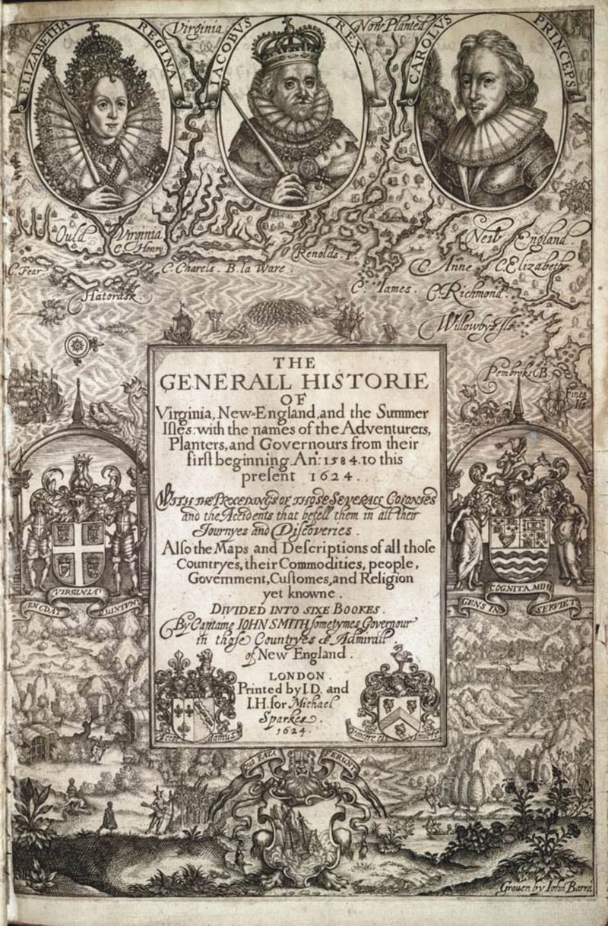FIGURE 1.1
Title page from Smith’s General History.

no entreaty could prevail, got his head in her arms, and laid her own upon his to save him from death: whereat the
Emperor was contented he should live. . . .

Two days after, Powhatan having disguised himself in the most fearefullest manner he could, caused Capt. Smith to be brought forth to a great house in the woods. . . then Powhatan. . . came unto him and told him now they were friends, and presently he should go to Jamestown, to send him two great guns, and a grindstone, for which he would give him the Country of Capahowosick, and forever esteem him as his son Nantaquoud.

Questions:

1. Sourcing: Who wrote this document? When? How much time passed between the writing of A True Relation
and General History?
2. Close Reading: According to the General History, did Pocahontas save John Smith’s life?

Section Questions:

1. Corroboration: How is the story in John Smith’s General History different then the story he tells in A True
Relation?
2. Why might John Smith have told the story differently in the two accounts?

The American Dream of Captain John Smith – J.A. Leo Lemay

Source: Excerpt from The American Dream of Captain John Smith, written in 1991 by historian J.A. Leo Lemay.

No one in Smith’s day ever expressed doubt about the episode, and may persons who must have known the truth—including
John Rolfe, Pocahontas, her sister, and brother-in-law—were in London in 1616 when Smith publicized the story in a letter to the queen. As for the exact nature of the event, it seems probable that Smith was being ritualistically killed. Reborn, he was adopted into the tribe, with Pocahontas as his sponsor. But Smith, of course, did not realize the nature of the initiation ceremony.

Question:

1. Sourcing: What kind of document is this? When was it written?
2. Close Reading: Does Lemay believe that Pocahontas saved John Smith? What evidence does he provide for his argument?

The Great Rogue – Paul Lewis

Source: Excerpt from The Great Rogue: A Biography of Captain John Smith, written by the historian Paul Lewis in
1966.

[Pocahontas] first steps onto the stage in 1617, a few months after she and her husband, John Rolfe, arrived in England. A charming, attractive, and exceptionally intelligent young woman, she created a sensation everywhere she went. Not only was she the daughter of a king and the first Indian woman ever to visit the British Isles, but as a convert to Christianity she aroused interest in circles that otherwise would have ignored her.

She discussed theology with bishops and with those learned scholars who were engaged in the monumental task of translating the Bible from Hebrew and Greek for King James, who had ordered a new edition published. She proved to the doubting dons of Oxford and Cambridge that she was an independent, stimulating thinker. Her beauty and sweetness endeared her to the court, where Queen Anne became her patroness, and even the sour James unbent and chatted with her by the hour.

While Pocahontas was enjoying her triumph, a new edition of John [Smith]’s True Relation was published. It was substantially the same book that had been printed eight years earlier, and the text was not altered. But there was something new in the form of a series of running footnotes in the section that dealt with his capture by the Chesapeake late in 1607. These notes tell the story, subsequently learned by generation after generation of children, of Pocahontas’ courage and heroism. . . . Without making the claim in so many words, he hints that he taught her to speak English and that she acquired her love of the Bible from him. . . .

A longer, more smoothly written version of the story appears in The General History of Virginia, which John

completed in 1624 and published in that same year. In it he expands on the theme that she rescued him at the risk of her own life. “Princess Pocahontas hazarded the beating out of her own brains to save mine,” he declares. “Not only that, but she so prevailed with her father that I was safely conducted to Jamestown.”

Questions:

1. Sourcing: What kind of document is this? When was it written?
2. Close Reading: Does Lewis believe that Pocahontas saved John Smith? What evidence does he provide to support his argument?

Section Question:

1. Corroboration: Which historian do you find more convincing, Lewis or Lemay? Why?

References

1. . http://docsouth.unc.edu/southlit/smith/smith.html. Public Domain

