A Prokaryotic Tour
You are about to take a tour of a cell. It will, sadly, be an imaginary tour, with some pictures thrown in for veracity, but it will hopefully help you visualize what a cell looks like, and how it functions. To start with, we are going to tour one of the most successful organisms on the planet: a bacterium. (Right now, you might be thinking something like" "I've heard of bacteria before..." Well, a bacterium is just the singular case for the word bacteria.)
Bacteria are an example of the oldest and most successful life form on our planet. Such prokaryotes have existed for billions of years, are found almost everywhere, and as a whole outnumber and outweigh us Humans by a huge factor.
Now, in order to get into a bacterium, you are going to have to be very, very small. Look at the tip of a mechanical pencil. If you make a mark on paper with that graphite, you get a spot that is usually about 0.5 millimeters across. A bacterium is about five thousand times smaller than that, so you will need to be extraordinarily tiny!
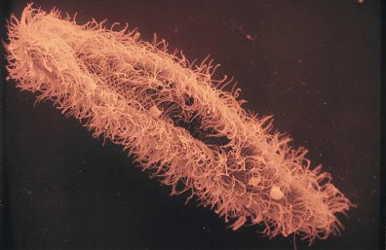
We will begin outside the bacteria. There are thousands of different cells near you, although you are so small that they seem far away. Some cells are clumped together, and some are moving around as individuals, but in all cases each cell makes up an individual organism, because bacteria are unicellular. (This just means that they are made of a single cell.) Some are moving around. Down below you is one that seems to be crawling along a surface. Its skin bulges, and swells, and reaches out like a weird leg or tentacle. This is a pseudopod, which lets the cell grab onto things and push and pull itself around.
Off to the side is a different sort of cell. It looks like it is covered with thousands of tiny thin structures. These things ripple and swing like tiny oars, pushing the cell forward. These are called cilia, which is a fancy way of saying they look like tiny hairs under a microscope. Past that is a sort of elongated, thin cell. It has a few long, curved tails sticking out of its back. Occasionally, the tails will spin around, and the cell will go shooting off in a long, curving path. For this cell, these "tails" act like a motor to push it around. Under a microscope, these thin projections look like small whips, so each one is named a flagellum, which is named after the Latin word for a whip.
Figure 1: cilia on a cell
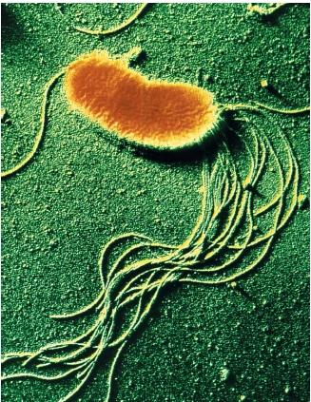
To make things easy, we can visit a bacterium that doesn't seem to be moving around much. One of those green ones up above should fit the bill. It would take some effort to swim over to it if we were actually there. When you're this small, water seems much thicker, and harder to move through. When you get up to the cell, you can see that it is covered with a thick, clunky looking plate. This forms a sort of box around the cell, something like armor. Here and there it has holes in it, and you can dimly see swirls of water diffusing in through cracks in some places, and being pumped out in others. It isn't quite clear, but is instead mostly translucent, and you can see shapes moving around inside. This is the cell wall. It protects the cell, and acts like an exoskeleton or shell. To get inside it, you'll have to enter through one of the holes (or pores) in the wall.
Figure 2: flagella on a cell
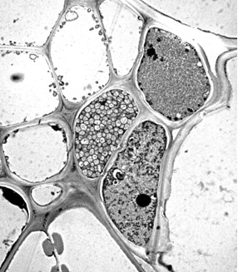
As you get closer, you can see what look like spikes sticking out through the cell wall, and a layer of slime covering it. At the pore, you are able to see some things poking through the skin of the cell. Some of them seem to be grabbing molecules from the water, and then pulling or moving them through to the inside of the cell. Others seem to be doing the opposite. These are cell surface transport proteins, and their only job is to act like pumps, moving specific molecules from one side of the cell membrane to the other. (When proteins in a cell membrane use energy to move molecules in or out of the cell, it is called active transport. Passive transport is when small holes open in the cell membrane to let things diffuse in or out without using energy.)
Figure 3: Cell walls
After a few seconds, you see a mouth of sorts open, and a cluster of junk is released through the pore. This is exocytosis, where the cell membrane grabs stuff inside a cell and moves it outside. Moving quickly, you reach the opening and grab one of the projections sticking through the membrane. As proteins shift and fold, the membrane closes up behind you, and then opens up in front. You've just undergone endocytosis, which is the opposite of exocytosis.
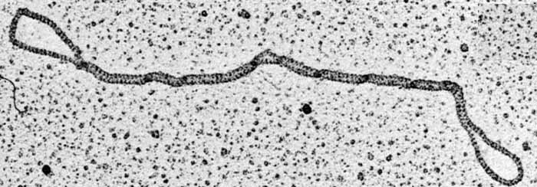
Before you is the interior of the cell, swirling with a thick mix of water, fats, sugars, proteins, and hundreds of other atoms and molecules. This jelly is called the cytoplasm. Off to the left is a large loop of a thick sort of ribbon. This is a chromosome: it is made of a chain of DNA. Here and there, you can see the two twisted, connected chains that make up DNA being unzipped from each other by some large proteins. Another protein attaches, and starts connecting rings of sugar connected to rings of nitrogen and branches of phosphate, matching them up with similar molecules in the DNA. This new chain being built is called RNA. After a bit, the matching new chain gets snipped off, and another huge molecule snatches it up while the DNA chains get zipped back together.
Figure 4: A loop of DNA chromosome
The huge molecule is a Ribosome, and it is also made of RNA, but it is put together differently. It feeds the smaller strand of RNA into itself, and begins spitting out a protein, which folds and scrunches up on itself as it emerges. In a bit, the last segment of the protein emerges, and it goes floating off. Looking in the direction it randomly moves in, you spot the other major part of the cell. There appears to be another membrane in here, folded over and over.
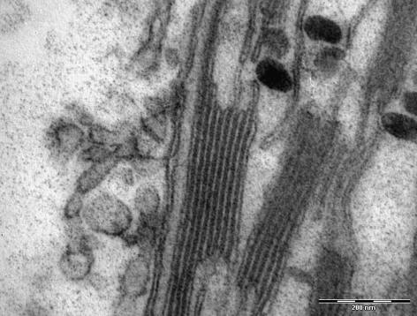
The other membrane is a bright green, and appears to be covered with lots of tiny machines made of protein. These proteins bend and snap, passing atoms and molecules through the green membrane. This is a thylakoid membrane. It is absorbing light, and as it does, the proteins on its surface change their shape. They twist, and fold, grab and carry hydrogen protons from the inside surface of the membrane to the outside. As they diffuse back to the inside, they spin a sort of wheel. As this wheel spins like a tiny gear, it grabs different molecules and snaps them together before releasing them, churning out a sort of cellular fuel. Later, this fuel is latched onto by other molecules: as the fuel breaks apart like a spring uncoiling, it forces water and carbon dioxide together to make sugar molecules. This process is known as photosynthesis.
Figure 5: Thylakoid Membrane
And really, that's it: a tour of a somewhat typical bacterium. It isn't identical to all other prokaryotes (which is the name for the groups of organisms that are tiny, unicellular, and don't have a special storage compartment called a nucleus for their DNA. Speaking of which...we'll talk soon, when we tour a eukaryote!
Explain the meaning of the following concepts using information from the reading:
- Prokaryote
- Bacterium
- Unicellular
Create a list of the 15 major structures and processes found in prokaryotes, and explain the features of each. Then, create a drawing that shows the structure or process using the description in the text.

